

Use Case Specification

|  |  |
| --- | --- |
| **Use Case ID** | **UC-001** |
| **Use Case Name** | **New Quote** |
| **Company** | **SteelBrick Valued Customer** |

**Revision History**

|  |  |  |  |
| --- | --- | --- | --- |
| Date | Version | Author | Description |
| 2/25/2015 | Draft | Don Fernando | Draft example of use case |
|  |  |  |  |
|  |  |  |  |
|  |  |  |  |

High-Level Description 3

Use Case Characteristics 3

Scenario 1 – Base Flow 4

Scenario 1 - Activity Diagram 4

Scenario 1 - Context Diagram 5

Scenario 1 - Test Script 6

Scenarios 2 – Alternate Flow 1 - Select Products 8

Scenario 2 - Activity Diagram 8

Scenario 2 - Context Diagram 8

Scenario 2 - Test Script 8

Scenarios 3 – Alternate Flow 2 - Discounts Applied, Request Approved 8

Scenario 3 - Activity Diagram 8

Scenario 3 - Context Diagram 8

Scenario 3 - Test Script 8

Scenarios 4 – Alternate Flow 3 - Discounts Applied, Request Rejected 8

Scenario 4 - Activity Diagram 8

Scenario 4 - Context Diagram 8

Scenario 4 - Test Script 8

Business Rules 8

# High-Level Description

The purpose of the use case is to produce a valid quote in the SteelBrick system.

# Use Case Characteristics

|  |  |
| --- | --- |
| Primary Actor | Sales Rep User |
| Trigger | Sales Rep User creates clicks ‘New Quote’ on the SteelBrick object |
| Pre-conditions | * An SFDC opportunity is successfully created |
| Post-conditions | * A quote with line items and pricing are associated with the SFDC opportunity * If the quote is marked as ‘Primary’, quote lines are sync’d to the opportunity’s lines. Certain quote level fields (ie. ACV, TCV) will be sync’d to opportunity |

# Scenario 1 – Base Flow

## Scenario 1 - Activity Diagram

## Macintosh HD:Users:dfernando:Desktop:Screenshots:Screen Shot 2015-02-24 at 5.48.53 PM.png

## Scenario 1 - Context Diagram

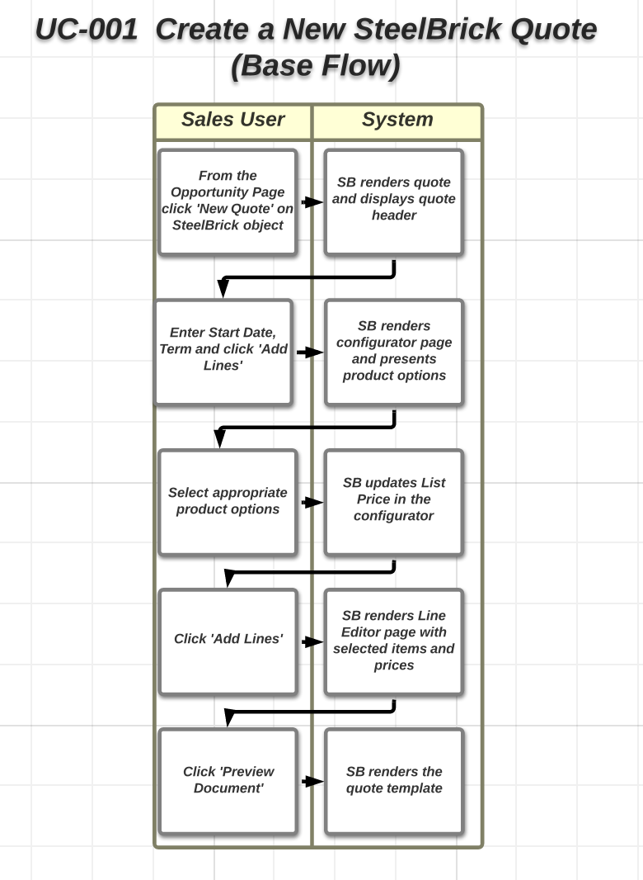

## Scenario 1 - Test Script

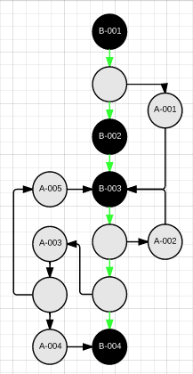

|  |  |  |  |  |  |  |  |  |
| --- | --- | --- | --- | --- | --- | --- | --- | --- |
| Step | Object | Action | Entered Value | Expected Result | Actual Result | Biz Rule | Status | Defect # |
| B-001.1 | Account | Sales user clicks ‘New Opportunity’ |  | Opportunity form presented |  |  |  |  |
| B-001.2 | Opportunity | Select Record Type | Enterprise Sales |  |  |  |  |  |
| B-001.3 |  | Populate Type |  |  |  |  |  |  |
| B-001.4 |  | Populate Stage | B – Discover |  |  |  |  |  |
| B-001.5 |  | Populate Close Date | 3/15/2015 |  |  |  |  |  |
| B-001.6 |  | Sales user clicks ‘Save’ |  |  |  |  |  |  |
| B-001.7 |  | Sales user clicks ‘New Quote’ on SteelBrick Quote |  | Quote Header form presented |  |  |  |  |
| B-001.8 | Quote | Check Primary |  |  |  |  |  |  |
| B-001.9 |  | Populate Start Date | 4/1/2015 |  |  |  |  |  |
| B-001.10 |  | Populate Subscription Term | 12 |  |  |  |  |  |
| B-001.11 |  | Sales user clicks ‘Save’ |  | Line Editor form presented |  |  |  |  |
| B-001.12 |  | Sales user clicks ‘Add Products’ |  | Configurator Page presented |  |  |  |  |
| B-002.1 | Configurator | Select *Product Option 1* |  |  |  |  |  |  |
| B-002.2 |  | Select *Product Option 3 - Subscription* |  |  |  |  |  |  |
| B-002.3 |  | Select *Product Option 3 - Service* |  |  |  |  |  |  |
| B-002.4 |  | Sales user clicks ‘Save’ |  | Line Editor form presented |  |  |  |  |
| B-003.1 |  | *Verify Line Item Price 1* |  | *List Price = $1200 Net Price = $1000* |  |  |  |  |
| B-003.2 |  | *Verify Line Item Price 2 - Subscription* |  | *List Price = $20 Net Price = $10* |  |  |  |  |
| B-003.3 |  | *Verify Line Item Price 3 - Service* |  | *List Price = $12 Net Price = $10* |  |  |  |  |
| B-003.4 |  | Verify Contact |  | Primary Contact on the Quote should be same as Primary Contact from Account |  | BR1 |  |  |
| B-003.5 |  | Sales user clicks ‘Save’ |  | Quote Header form presented |  |  |  |  |
| B-004.1 | Quote | Sales user clicks ‘Preview Document’ |  | Quote Template form presented |  |  |  |  |
| B-004.2 |  | Select ‘Proposal’ |  |  |  |  |  |  |
| B-004.3 |  | Sales user clicks ‘Continue’ |  | Proposal rendered |  |  |  |  |
| B-004.4 |  | *Verify Quote Header* |  |  |  |  |  |  |
| B-004.5 |  | *Verify Bill To* |  | *Matches Ship to from Quote* |  |  |  |  |
| B-004.6 |  | *Verify Contact* |  | *Matches Primary Contact on Quote* |  | *BR1* |  |  |
| B-004.7 |  | *Verify Line Items* |  | *Matches Line Items on Quote* |  |  |  |  |
| B-004.8 |  | *Verify Subscription Terms* |  | *Matches Subscription Terms on Quote if present* |  | *BR2* |  |  |
| B-004.9 |  | *Verify Prices* |  | *Matches Prices on Quote* |  |  |  |  |
| B-004.10 |  | *Verify Signature Block* |  |  |  |  |  |  |
| B-004.11 |  | *Verify Quote Terms - Service* |  | SLA content shown if service items present on quote |  | BR3 |  |  |

# Scenarios 2 – Select Products

## Scenario 2 - Activity Diagram

## Scenario 2 - Context Diagram

## Scenario 2 - Test Script

# Scenarios 3 – Discounts Applied, Request Approved

## Scenario 3 - Activity Diagram

## Scenario 3 - Context Diagram

## Scenario 3 - Test Script

# Scenarios 4 – Discounts Applied, Request Rejected

## Scenario 4 - Activity Diagram

## Scenario 4 - Context Diagram

## Scenario 4 - Test Script

# Business Rules

|  |  |  |
| --- | --- | --- |
| ID | Business Rule Name | Business Rule Description |
| BR1 | Contact on Proposal | Primary Contact from the Account must populate on the Proposal |
| BR2 | Showing Subscription Terms | If subscription products exist on the quote then the terms must appear on the proposal, otherwise do not show the subscription section on the proposal |
| BR3 | Service Terms | If service items are included on the quote then display Service Level Agreement content |
| BR4 | Any discounts need approval | Any discounts need to be submitted to VP Sales for approval |
| BR5 | Ability to print proposal after Approvals | Proposal cannot be generated if discounts applied are not approved |